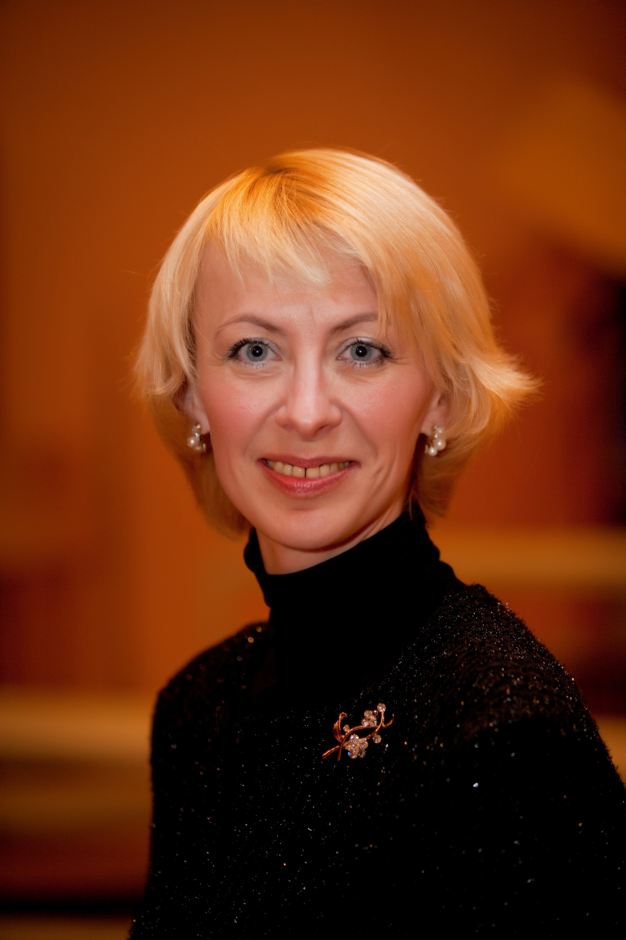 Inessa Bodyako
was born in 1972 in the city of Vitebsk. The graduate of the Belarus state academy of music (a class of professor Victor Rovdo). Inessa Bodyako is the head of chair of choral conducting, the art director of student’s chorus, teaches choral conducting and the history of Russian choral music in Belarusian State Academy of music. She was a chorus master of the Academic chorus of National television and radio broadcasting company of Republic of Belarus, founder and conductor of Chamber chorus “Cantemus” becoming the prize-winner of the international choral competitions in Italy (Arezzo, Gorizia), Spain (Tolosa), Poland (Hajnowka), Belarus (Minsk). She won the Prize to "the Best conductor" on V International festival of orthodox church chanting (Minsk, Belarus) and XXXIX International choral competition "C.A.Seghizzi" (Gorizia, Italy). Inessa was the juror of many republican and international competitions, gave master classes in Germany, France, was responsible for a great number of choral projects in Belarus including Open Conductor’s competition named after V. Rovdo, Choral pages of the XX-th century, female chorus “Magic Lillies”. Email: inesminsk@tut.by

Creative activity:
• the chorus master of academic chorus of National television and radio broadcasting company of Republic of Belarus (2001-2008)
• the art director of youth chamber chorus «Cantemus» (2000-2005)
• the regent of an orthodox temple in honour of Christmas Christ's д. B.Stiklevo (1998 on the present moment).
• the art director of student's chorus of the Belarus state academy of music (with 2007).

Author's projects:
• Choral pages of the XX-th century:
✓ The Polish page (conductor Martha Vitchak-Kerska (Wroclaw), September 2006, the Small hall of G.Shirmy, Minsk);
✓ The Swiss page (conductor Rajner Held (Lucerne) February 2009, the Small hall of G.Shirmy, Minsk);
✓ The Bulgarian page (the conductor, composer Dragomir Nenov (Sofia), May 2010, the Small hall of G.Shirmy, Minsk).
• 1 Open competition of choral conductors of a name of the national artist of the USSR, professors V.V. Rovdo (November 2009, BSAM, Minsk).
Student's scientifically-practical conference «Choral performanse: traditions and the present» (BSAM, Minsk, on November, 25-27th 2010)

• Master Classes of many conductors from Poland, Swiss, Bulgaria, USA, Austria, Germany for students of department of choral conducting BSAM.
• Female chorus «Magic Lillies».

Disks:
• Chorus of an orthodox temple in honour of Christmas Christ's (Minsk):
✓ The Pray uplift to the Lord (1999)
✓ Acathistus to Mother of God
✓ The Acathistus To Serafimu Sarovsky
✓ The Acathistus to the Minsk icon of Mother of God
✓ The Acathistus to Christmas Ioann Baptisma (2007)
✓ Under Your favour we resort (2006)
• Youth chamber chorus «Cantemus»:
✓ Senza confini - Without borders (2002)
✓ Sing Its name (2003)

• Student's chorus of the Belarus state academy of music:
✓ W.A.Mozart the Mass to-minor (2007)
✓ A.Kiselev a choral concert «Russian wedding» (2009) DVD
✓ G.F.Hendel an oratorio «Israel in Egypt» (2010)

Awards:
The winner of the international choral competitions:
• VII International festival of sacred music Might God (Mogilyov, Belarus, on July, 3-16rd, 1999) - the first award in a category of parish choruses;
• V International festival of orthodox church chanting (Minsk, Belarus, on May, 17-21th, 2000):
✓ Gran-Prix;
✓ The Prize to "the Best conductor".
• XXXIX International choral competition "C.A.Seghizzi" (Gorizia, Italy, on July, 14-17th, 2000):
✓ Gran-Prix (a cup and the diploma);
✓ The first award in a monographic category (a cup and the diploma);
✓ The third award in a historical category (a cup and the diploma);
✓ A cup "Rachele Basuno" for the best execution of the spiritual composition;
✓ Award U.S.C.I. del Friuli Venezia Giulia "the Best conductor" competition.
• the International choral competition "European Gran Prix" (Debrecen, Hungary, on July, 26-30th, 2001)
• XXI International festival of church music (Hajnuvka, Poland, on May, 21-28st, 2002) - the first award in a category chamber professional choruses.
• XXXXX International choral competition (Arezzo, Italy, on August, 21-24st, 2002) - the second award in a category "Christian monody".
• XXXV International choral competition (Тolosa, Spain, on October, 27 - on November, 3rd, 2003) - the second award in ensamble categories with execution russian sacred music.
• XXXXIII International choral competition "C.A.Seghizzi" (Gorizia, Italy, on July, 5-9th, 2004):
✓ II award in a monographic category with execution of fragments of the Symphony-action Gavrilin's "Ringing";
✓ III award in ensamble categories with execution of products of Russian composers of the XX-th century;
✓ III award in categories with execution of music by D.Bortnjansky, A.Shnitke, K.Penderetsky.
• the Reading and writing of the International Festival of Orthodox church chanting, signed by metropolitan Philaret (February, 2005).
• VI International competition of choral collectives «Singing world» J.A.Falika's name (St.-Petersburg, Russia, on July, 30th - on August, 4th, 2010):
✓ Gran-Prix;
✓ II award in a category "Sacred music";
✓ II award in a category «Homogeneous choruses»;
✓ I award in a category «Modern music»;
✓ A prize of spectator liking.

• VI International HARMONIE FESTIVAL 2011 (Limburg, Germany, on June, 2-6th, 2011):
- The gold certificate – I award- “Participated with outstanding success” in the category «Youth Choirs»;
- The gold certificate – I award- “Participated with outstanding success” in the category «Female Chamber Choirs»;
- The gold certificate – III award- “Participated with outstanding success” in the category «Mixed Choirs».

Contacts:
Phone: (+375) 29 124 09 47
E-mail: inesminsk@tut.by
ICQ #: 568592858

